**Big O Notation, Omega Notation, Theta Notation**

We have discussed Asymptotic Analysis, and Worst, Average, and Best Cases of Algorithms. The main idea of asymptotic analysis is to have a measure of the efficiency of algorithms that don’t depend on machine-specific constants and don’t require algorithms to be implemented and time taken by programs to be compared. Asymptotic notations are mathematical tools to represent the time complexity of algorithms for asymptotic analysis. The following 3 asymptotic notations are mostly used to represent the time complexity of algorithms.   
  
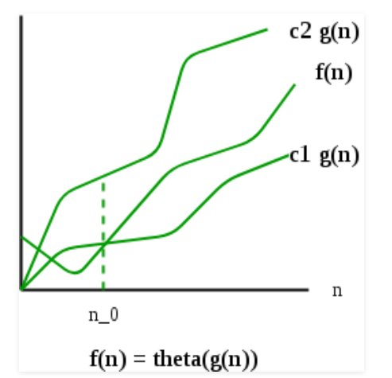  
  
**1) Θ Notation:**  
  
The theta notation bounds a function from above and below, so it defines exact asymptotic behavior.   
A simple way to get the Theta notation of an expression is to drop low-order terms and ignore leading constants. For example, consider the following expression.   
3n3 + 6n2 + 6000 = Θ(n3)   
Dropping lower order terms is always fine because there will always be a number(n) after which Θ(n3) has higher values than Θ(n2) irrespective of the constants involved.   
For a given function g(n), we denote Θ(g(n)) is following set of functions.   
  
  
Θ(g(n)) = {f(n): there exist positive constants c1, c2 and n0 such   
that 0 <= c1*g(n) <= f(n) <= c2*g(n) for all n >= n0}  
The above definition means, if f(n) is theta of g(n), then the value f(n) is always between c1*g(n) and c2*g(n) for large values of n (n >= n0). The definition of theta also requires that f(n) must be non-negative for values of n greater than n0.   
  
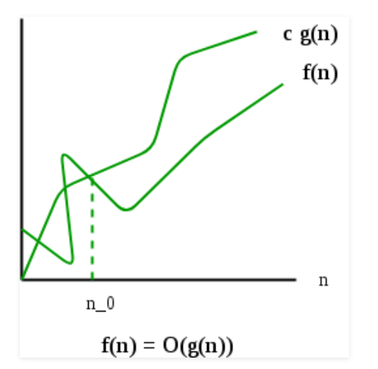  
  
  
**2) Big O Notation:**   
  
The Big O notation defines an upper bound of an algorithm, it bounds a function only from above. For example, consider the case of Insertion Sort. It takes linear time in the best case and quadratic time in the worst case. We can safely say that the time complexity of Insertion sort is O(n^2). Note that O(n^2) also covers linear time.   
  
If we use Θ notation to represent time complexity of Insertion sort, we have to use two statements for best and worst cases:   
1. The worst-case time complexity of Insertion Sort is Θ(n^2).   
2. The best case time complexity of Insertion Sort is Θ(n).   
  
The Big O notation is useful when we only have an upper bound on the time complexity of an algorithm. Many times we easily find an upper bound by simply looking at the algorithm.   
  
O(g(n)) = { f(n): there exist positive constants c and   
n0 such that 0 <= f(n) <= c*g(n) for   
all n >= n0}  
  
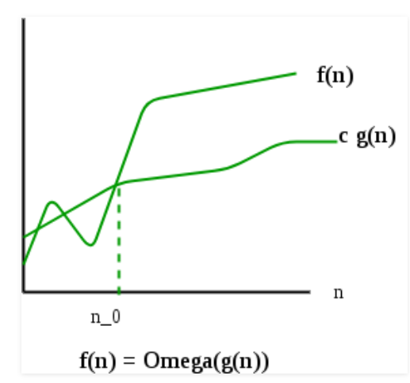  
  
  
**3) Ω Notation:**   
  
Just as Big O notation provides an asymptotic upper bound on a function, Ω notation provides an asymptotic lower bound.   
Ω Notation can be useful when we have a lower bound on the time complexity of an algorithm. As discussed in the previous post, the best case performance of an algorithm is generally not useful, the Omega notation is the least used notation among all three.   
  
For a given function g(n), we denote by Ω(g(n)) the set of functions.   
  
Ω (g(n)) = {f(n): there exist positive constants c and  
n0 such that 0 <= c*g(n) <= f(n) for  
all n >= n0}.  
Let us consider the same Insertion sort example here. The time complexity of Insertion Sort can be written as Ω(n), but it is not very useful information about insertion sort, as we are generally interested in worst-case and sometimes in the average case.   
  
  
**Properties of Asymptotic Notations :**  
  
As we have gone through the definition of these three notations let’s now discuss some important properties of those notations.   
  
**1. General Properties :**  
  
If f(n) is O(g(n)) then a*f(n) is also O(g(n)) ; where a is a constant.   
  
Example: f(n) = 2n²+5 is O(n²)   
then 7*f(n) = 7(2n²+5) = 14n²+35 is also O(n²) .  
  
Similarly, this property satisfies both Θ and Ω notation.   
  
  
We can say   
If f(n) is Θ(g(n)) then a*f(n) is also Θ(g(n)) ; where a is a constant.   
If f(n) is Ω (g(n)) then a*f(n) is also Ω (g(n)) ; where a is a constant.  
  
  
**2. Transitive Properties :**  
  
If f(n) is O(g(n)) and g(n) is O(h(n)) then f(n) = O(h(n)) .  
  
Example: if f(n) = n, g(n) = n² and h(n)=n³  
n is O(n²) and n² is O(n³)  
then n is O(n³)  
  
Similarly, this property satisfies both Θ and Ω notation.  
  
We can say  
If f(n) is Θ(g(n)) and g(n) is Θ(h(n)) then f(n) = Θ(h(n)) .  
If f(n) is Ω (g(n)) and g(n) is Ω (h(n)) then f(n) = Ω (h(n))  
  
  
**3. Reflexive Properties :**  
  
Reflexive properties are always easy to understand after transitive.  
  
If f(n) is given then f(n) is O(f(n)). Since MAXIMUM VALUE OF f(n) will be f(n) ITSELF !  
  
Hence x = f(n) and y = O(f(n) tie themselves in reflexive relation always.  
  
Example: f(n) = n² ; O(n²) i.e O(f(n))  
  
Similarly, this property satisfies both Θ and Ω notation.  
  
We can say that:  
  
If f(n) is given then f(n) is Θ(f(n)).  
  
If f(n) is given then f(n) is Ω (f(n)).  
  
  
**4. Symmetric Properties :**  
  
  
If f(n) is Θ(g(n)) then g(n) is Θ(f(n)) .   
  
  
Example: f(n) = n² and g(n) = n²   
then f(n) = Θ(n²) and g(n) = Θ(n²)   
  
  
This property only satisfies for Θ notation.  
  
  
**5. Transpose Symmetric Properties :**   
  
  
If f(n) is O(g(n)) then g(n) is Ω (f(n)).   
  
  
Example: f(n) = n , g(n) = n²   
then n is O(n²) and n² is Ω (n)   
  
This property only satisfies O and Ω notations.  
  
  
**6. Some More Properties :**  
  
1.) If f(n) = O(g(n)) and f(n) = Ω(g(n)) then f(n) = Θ(g(n))  
  
2.) If f(n) = O(g(n)) and d(n)=O(e(n))   
then f(n) + d(n) = O( max( g(n), e(n) ))   
Example: f(n) = n i.e O(n)   
d(n) = n² i.e O(n²)   
then f(n) + d(n) = n + n² i.e O(n²)  
  
3.) If f(n)=O(g(n)) and d(n)=O(e(n))   
then f(n) * d(n) = O( g(n) * e(n) )   
Example: f(n) = n i.e O(n)   
d(n) = n² i.e O(n²)   
then f(n) * d(n) = n * n² = n³ i.e O(n³)  
  
  
  
**Exercise:**  
  
Which of the following statements is/are valid?   
1. Time Complexity of QuickSort is Θ(n^2)   
2. Time Complexity of QuickSort is O(n^2)   
3. For any two functions f(n) and g(n), we have f(n) = Θ(g(n)) if and only if f(n) = O(g(n)) and f(n) = Ω(g(n)).   
4. Time complexity of all computer algorithms can be written as Ω(1)

**Answer:**Option 2,3 and 4 are valid